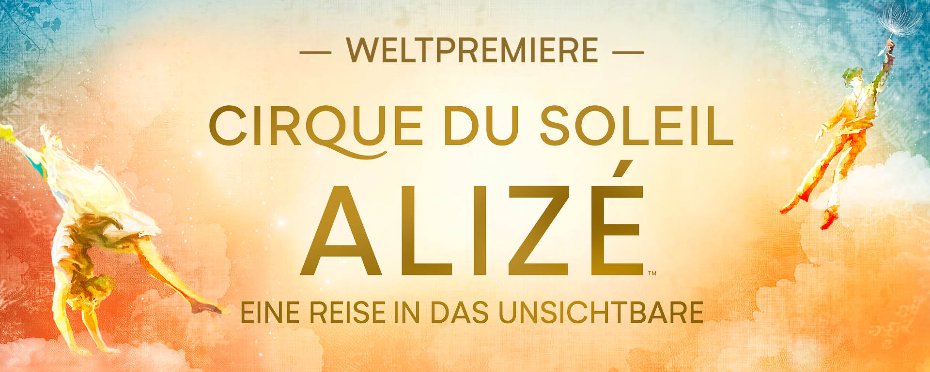

World premiere of Cirque du Soleil ALIZÉ™ in Berlin
from November 2025 at the Theater am Potsdamer Platz

First permanent European Cirque du Soleil show

Berlin, November 20, 2024 – Cirque du Soleil announces the world premiere of its first permanent European show ALIZÉ, which opens in November 2025 at the Theater am Potsdamer Platz in Berlin. The new show depicts a journey into the unseen with a mix of groundbreaking artistry and breathtaking magic, embedded in an adventure that pushes the boundaries of the imagination. Tickets for the new production, presented and co-produced by Live Nation, are on sale from November 22, 2024 at berlin.cirquedusoleil.de.

ALIZÉ is the 54th original production and the first resident show in Europe for Cirque du Soleil, which first opened its doors in Germany 30 years ago. Since 1995, a new era began with Saltimbanco, with 16 productions appearing in the Grand Chapiteau or arenas in 16 German cities. With its cosmopolitan and international appeal, Berlin is the ideal location for the first permanent Cirque du Soleil show in a European metropolis.

In this new, innovative creation, the protagonists embark on a journey into a surreal world. In trying to reveal the invisible, they discover the hidden magic that lies behind reality. Their poetic journey is filled with wonder, mystery and enchantment, inviting the audience to join them in a world where the impossible becomes possible. Cirque du Soleil ALIZÉ celebrates the magic of humanity through captivating acrobatic performances and magical visuals that dissolve the boundaries between reality and imagination.

The Theater at Potsdamer Platz will be redesigned to meet the unique technical requirements of this permanent production.

Cirque du Soleil's first permanent show in Europe will be seen at the Theater am Potsdamer Platz from November 2025. The shows are Wednesday at 6:30 p.m., Thursday at 7:30 p.m., Friday and Saturday at 4:00 p.m. and 8:00 p.m., Sunday at 1:00 p.m. and 5:00 p.m. There are no shows on Mondays and Tuesdays. To purchase tickets, visit berlin.cirquedusoleil.de.
About Cirque du Soleil Entertainment Group
Cirque du Soleil Entertainment Group is a world leader in live entertainment. Building on four decades of pushing the boundaries of the imagination, the artistic entertainment company brings its creative approach to a large variety of artistic forms such as live shows, multimedia productions, long-from content, music, immersive experiences, and special events. Cirque du Soleil Entertainment Group celebrates 40 years of defying reality, defining entertainment, and illuminating the world through art and creativity. Since its creation in 1984, more than 400 million people have been inspired on 6 continents and 86 countries. The Canadian company now employs more than 4000 employees, including 1200 artists from more than 80 different nationalities. For more information about Cirque du Soleil Entertainment Group, please visit cirquedusoleil.com.

About Live Nation Entertainment
Live Nation Entertainment (NYSE: LYV) is the world’s leading live entertainment company comprised of global market leaders: Ticketmaster, Live Nation Concerts, and Live Nation Sponsorship. For additional information, visit www.livenationentertainment.com.

For more information:

Cirque du Soleil Entertainment Group Live Nation GSA, Director Promotion
Ann Paladie Katharina Wenisch
ann.paladie@cirquedusoleil.com katharina.wenisch@livenation.de

livenation.de
berlin.cirquedusoleil.de
cirquedusoleil.com
ticketmaster.de
eventim.de

